LIBRARY MANAGEMENT SYSTEM
PROJECT REPORT
Project Report Submitted as Part of the Online Internship Program
Submitted by
NAME: Rakesh Patwardhan
USN : 4JK24EC080
Department: Electronics and communication Engineering
College: AJ Institute Of Engineering And Technology
Internship Guide/Mentor: Nitin
Internship Organization/ Platform: Corizo EduTech Private Limited
Internship Duration: 08/09/2026--05/10/2026
Academic Year: 2026–2027

TABLE OF CONTENTS
- Abstract
- Introduction
- Problem Statement
- Objectives
- Scope of the Project
- Existing System
- Proposed System
- Data Structures Used
- Algorithms Used
- Programming Language
- Software Requirements
- Hardware Requirements
- Functional Requirements
- Non-Functional Requirements
- Modules
- System Architecture
- Flowchart
- Algorithm / Pseudocode
- Database / File Structure
- Implementation Details
- Complexity Analysis
- Test Cases
- Output Screenshots
- Advantages
- Limitations
- Future Scope
- Conclusion

1. ABSTRACT
The Library Management System is a Python-based application developed to simplify and manage the basic activities of a library. The system provides a graphical user interface using Tkinter and stores information in an SQLite database. It is designed to help a librarian maintain book records, student details, and borrowing transactions in an organized manner.
The application supports adding, deleting, searching, and displaying books. It also allows the registration and searching of students, issuing books, and processing returned books. During an issue or return operation, the system updates the number of available copies to maintain accurate inventory records. The application includes reporting facilities for inventory, active issues, overdue books, and transaction history.
The project is divided into modules for authentication, database management, book management, student management, transactions, and reports. A login mechanism protects access to the librarian interface, and password verification uses a salted PBKDF2-HMAC-SHA256 hash. SQLite provides persistent storage, while database transactions help maintain consistency during book issue and return operations.
This project demonstrates the practical application of Python programming, database operations, modular software design, searching, and transaction handling. It provides a foundation for a library system that can be enhanced in the future with additional features such as barcode scanning, automated notifications, and multi-user access.
Keywords: Library Management System, Python, Tkinter, SQLite, Data Structures and Algorithms.

2. INTRODUCTION
Libraries play an important role in educational institutions by providing students and staff with access to books and other learning resources. Managing a library involves maintaining book records, tracking available copies, registering students, and recording the issue and return of books. When these activities are performed manually, maintaining accurate records and retrieving information can become time-consuming.
The Library Management System is a Python-based application developed to simplify these activities through a graphical user interface. It uses Tkinter to provide an interactive desktop interface and SQLite to store information persistently. The system allows the librarian to manage books and student details, issue and return books, search records, and generate reports.
The application is organized into separate modules for authentication, database operations, book management, student management, transactions, and reporting. This modular structure makes the program easier to understand, test, maintain, and extend.
The project demonstrates the practical use of Python programming, database management, modular design, searching operations, and transaction handling in a real-world application.
3. PROBLEM STATEMENT
Managing library records manually can create difficulties in maintaining book inventories, tracking borrowed books, identifying overdue returns, and retrieving student or transaction information. Manual record keeping may also lead to errors in the number of available copies and make it difficult to prepare accurate reports.
Therefore, there is a need for a computerized system that organizes library information, simplifies routine operations, maintains consistent inventory records, and provides convenient access to book, student, and transaction details.
The proposed Library Management System addresses these problems by providing a graphical interface and a centralized SQLite database for managing books, students, issue and return transactions, and reports.
4. OBJECTIVES
The main objectives of the Library Management System are:
- To develop a user-friendly desktop application for managing library activities.
- To provide secure librarian authentication using password hashing.
- To add, delete, search, and display book records.
- To register students and retrieve student information.
- To implement book issue and return operations.
- To update book availability automatically when books are issued or returned.
- To maintain library information in an SQLite database.
- To generate inventory, active-issue, overdue, and transaction-history reports.
- To organize the application into separate modules for easier maintenance and testing.
- To demonstrate the practical application of programming and database concepts in a library environment.
5. SCOPE OF THE PROJECT
The scope of this project covers the basic management activities of a library through a desktop application.
Included features:
- Librarian login and authentication.
- Adding, deleting, searching, and displaying books.
- Student registration and student search.
- Issuing books to registered students.
- Recording returned books and updating available-copy counts.
- Displaying currently active borrowing records.
- Generating inventory, active-issue, overdue, and transaction-history reports.
- Storing records persistently using SQLite.
Limitations of the current scope:
- The application is designed as a desktop system rather than a web-based application.
- The current implementation focuses on librarian operations.
- Online reservations, barcode scanning, automated email or SMS notifications, and online fine payments are not implemented.
- Advanced multi-branch library management and cloud synchronization are outside the current scope.
These limitations can be addressed in future versions of the system.
6. EXISTING SYSTEM
The traditional library management system often relies on manual registers, paper records, or basic spreadsheet files to maintain information about books, students, and borrowing transactions. The librarian must manually record book issues and returns, check book availability, and maintain transaction details.
Managing a large number of records through manual methods can be time-consuming. Searching for a particular book or student may require examining multiple records. Manual updates can also lead to inconsistencies in inventory information, misplaced records, and difficulties in identifying overdue books.
Preparing reports about available books, active borrowing records, and transaction history may require additional effort. These limitations indicate the need for a computerized system that can organize library information and simplify routine library operations.
7. PROPOSED SYSTEM
The proposed Library Management System is a desktop application developed using Python. It provides a graphical user interface through Tkinter and uses SQLite for persistent data storage. The application organizes library operations into separate modules for authentication, book management, student management, issue and return processing, and reporting.
The system allows the librarian to add, delete, search, and display book records. Student details can be registered and searched. Books can be issued to registered students and returned through the application. The available-copy count is updated during issue and return operations to maintain consistent inventory information.
The reporting module provides inventory reports, active-issue reports, overdue reports, and transaction-history reports. Password verification uses a salted PBKDF2-HMAC-SHA256 hash. Database transactions are used during issue and return operations to help maintain data consistency.
The proposed system reduces reliance on manual record keeping and provides an organized way to retrieve and manage library information. Its modular design also supports easier testing, maintenance, and future enhancement.

8. DATA STRUCTURES USED
The Library Management System uses Python data-handling mechanisms and SQLite database structures to manage records.
1. Lists
Python lists are used where collections of records are retrieved or processed by the application. They can hold multiple book, student, or transaction records returned from database queries.
2. Tuples
SQLite query results are commonly returned as tuples. These tuples contain fields such as book ID, title, author, and availability information. The application can access individual fields to display or process the records.
3. Dictionaries and key-value mappings
Dictionary-style mappings may be used to associate field names with values where supported by the application code. Such mappings make record handling more readable when retrieving database results by column name.
4. Relational tables
SQLite stores books, students, users, and transactions in relational tables. Primary keys identify records, while foreign keys establish relationships between borrowing transactions, books, and students.
5. Database indexes
Indexes on book title and author, along with the student identifier in transaction records, support more efficient retrieval for relevant database queries.
The project primarily relies on Python collections and SQLite's relational storage. Linked lists, stacks, queues, trees, and hash tables should be described as implemented data structures only if they are explicitly used in the source code.

9. ALGORITHMS USED
The Library Management System implements several basic algorithms and database operations to manage library records.
1. Book Searching
The application searches for books using identifying information such as book ID, title, or author. The search operation uses database queries to retrieve matching records. Its performance depends on the query conditions, available indexes, and number of matching records.
2. Book Insertion
When a new book is added, the application validates the supplied information and inserts a record into the books table. The record contains the title, author, category, total number of copies, and available number of copies.
3. Book Deletion
The application identifies the selected book and checks whether transaction history exists for it. A book with borrowing history is protected from deletion to preserve transaction records.
4. Book Issue
The issue operation checks whether the selected book and student exist and whether a copy is available. If the checks succeed, a transaction record is created and the available-copy count is decreased. Database transaction handling helps prevent partial updates.
5. Book Return
The return operation checks whether the transaction exists and has not already been returned. It records the return date and increases the available-copy count. It also calculates late-return days where applicable.
6. Report Generation
Database queries retrieve inventory, active issues, overdue transactions, and transaction history. The application formats the retrieved records for display in the reporting interface.
No separate sorting algorithm such as Bubble Sort, Merge Sort, or Quick Sort should be claimed unless it has been implemented explicitly in the source code.
10. PROGRAMMING LANGUAGE
Python is the primary programming language used to develop the Library Management System. Python was selected because of its readable syntax, extensive standard library, and suitability for developing desktop applications and database-driven programs.
The application uses Python's Tkinter library to create the graphical user interface. The sqlite3 module provides connectivity to the SQLite database for storing and retrieving library records. Other standard Python modules are used for password hashing, date handling, and application logic.
The program is divided into separate modules to improve readability, maintainability, testing, and code organization. This modular approach allows book management, student management, authentication, transactions, and reporting to be handled independently.

11. SOFTWARE REQUIREMENTS
The following software components are used to develop and execute the Library Management System.
- Operating System: Microsoft Windows 11.
- Programming Language: Python.
- Development Environment: Visual Studio Code.
- Graphical User Interface: Tkinter.
- Database Management System: SQLite.
- Database Connectivity: Python sqlite3 module.
- Additional Packages: No third-party packages are required for the current implementation, provided the necessary Python standard-library components are available.
The software environment supports application development, database management, debugging, and execution of the Library Management System.

12. HARDWARE REQUIREMENTS
The Library Management System can run on a standard personal computer capable of executing Python and a desktop graphical user interface.
Component | Suggested Requirement
Processor | Dual-core processor or equivalent
RAM | 4 GB minimum
Storage | Approximately 100 MB of free space for the application and its initial database, with additional space as records grow
Display | Standard monitor supporting the desktop interface
Input Devices | Keyboard and mouse
Operating System | Windows 10 or Windows 11
The exact requirements depend on the operating system, installed Python environment, and size of the library database. The application does not require a dedicated graphics card for its normal operations.

13. FUNCTIONAL REQUIREMENTS
Functional requirements describe the operations provided by the Library Management System.
- Login: The system must allow an authorized librarian to log in using valid credentials.
- Add Book: The librarian must be able to enter and save book details.
- Delete Book: The librarian must be able to delete an eligible book record while protecting records with transaction history.
- Search Book: The system must support searching for books using available identifying information.
- Display Books: The application must display stored book records and their availability.
- Student Management: The librarian must be able to register students and search student records.
- Issue Book: The system must verify book availability and student existence before issuing a book.
- Return Book: The system must record book returns and update the available-copy count.
- Active-Issue Display: The system must display current borrowing transactions.
- Reports: The system must generate inventory, active-issue, overdue, and transaction-history reports.
- Data Persistence: Book, student, user, and transaction records must be stored in the SQLite database.
- Data Consistency: The system must maintain consistent inventory counts during issue and return operations.

14. NON-FUNCTIONAL REQUIREMENTS
Non-functional requirements describe the quality attributes of the Library Management System.
1. Performance
The system should retrieve and display records efficiently for the expected size of a small library database. Database queries and indexes support record retrieval.
2. Reliability
The application should maintain accurate records and prevent invalid issue or return operations. Database transaction handling helps maintain consistency when updating borrowing records and book availability.
3. Security
The login module verifies passwords using salted PBKDF2-HMAC-SHA256 hashes rather than storing plaintext passwords. Access is intended for authorized librarian operations.
4. Maintainability
The application is divided into separate modules for database management, authentication, books, students, transactions, and reports. This separation makes the code easier to understand and modify.
5. Scalability
The modular design and SQLite database provide a foundation for future enhancements. Larger deployments may require additional database and application architecture changes.
6. Usability
The Tkinter graphical interface provides forms, buttons, tabs, and tables to help the librarian perform routine operations without directly entering SQL commands.

15. MODULES
The Library Management System is divided into separate modules, each responsible for a specific set of operations. This modular design improves code organization, testing, and maintainability.
15.1 Login Module
The login module provides authentication for the librarian. It verifies the entered username and password against the stored credentials. Passwords are verified using salted PBKDF2-HMAC-SHA256 hashes.
15.2 Book Management Module
The book management module supports adding, deleting, searching, and displaying books. It stores book information such as book ID, title, author, category, total copies, and available copies. Deletion is restricted when transaction history exists for a book.
15.3 Student/User Management Module
The student management module allows the librarian to register students, view student records, and search for students. Each student is assigned a unique identifier.
15.4 Issue/Return Module
This module manages borrowing transactions. When a book is issued, the system checks book availability and student validity, creates a transaction record, and decreases the available-copy count. When a book is returned, the system records the return date and increases the available-copy count.
15.5 Search Module
The search functionality allows the librarian to locate books and students using supported search fields. Book searches can use the book ID, title, or author, while student searches use the fields supported by the implementation.
15.6 Report Module
The report module provides inventory reports, active-issue reports, overdue reports, and transaction-history reports. These reports help the librarian review the current status of the library and its borrowing activities.

16. System Architecture
Librarian
Enters information and select operations

Tkinter Graphical user Interface
Login · Books · Students · Issue/Return · Reports

Python Application Modules
Main.py · auth.py · book_manager.py · student_manager.py · transaction.py · reports.py

database.py
Database initialization and connection management

SQLite Database---library.db
Users · Books · Students · Transactions

Figure 1: System Architecture of the Library Management System
System Architecture Explanation
The Library Management System follows a modular desktop application architecture. The librarian interacts with the application through a graphical user interface developed using Tkinter. The interface invokes Python modules responsible for authentication, book management, student management, transactions, and reports.
The database module manages connections to the SQLite database and initializes the required tables. The database stores user credentials in hashed form, book details, student information, and borrowing transactions. Primary-key and foreign-key relationships connect the relevant records.
When the librarian performs an operation, the application validates the request, executes the required logic, interacts with the database, and displays the result through the interface. This separation of responsibilities makes the application easier to maintain and test.
17. FLOWCHART

Figure 2: Flowchart of the Library Management System

Flowchart Explanation
The workflow begins when the application displays the login screen. The librarian enters credentials, and the authentication module validates them. If the credentials are invalid, an error is displayed and the user can attempt to log in again. If authentication succeeds, the dashboard is opened.
The librarian selects an operation such as book management, student management, issue/return processing, or report generation. The corresponding module validates the request and performs the required database operation. The result is then displayed through the graphical interface.

18. ALGORITHM / PSEUDOCODE
18.1 Algorithm for Librarian Login
Input: Username and password
Output: Login success or failure
Steps:
- Start the login process.
- Accept the username and password entered by the librarian.
- Retrieve the account associated with the username.
- If the account does not exist, display a login error.
- Otherwise, verify the entered password against the stored password hash.
- If verification fails or the account does not have the required librarian role, reject the login.
- Otherwise, open the main dashboard.
- End the login process.
Pseudocode:
START
INPUT username, password
account ← FIND ACCOUNT BY USERNAME
IF account does not exist THEN
DISPLAY "Invalid credentials"
ELSE
IF VERIFY PASSWORD(password, account.password_hash) AND account.role = "librarian" THEN
DISPLAY DASHBOARD
ELSE
DISPLAY "Invalid credentials"
END IF
END IF
STOP
18.2 Algorithm for Searching Books
Input: Search keyword
Output: Matching book records
Steps:
- Start the search operation.
- Accept a search keyword from the librarian.
- Search the database using the supported book search fields.
- Retrieve the matching records.
- If no records match, display an appropriate message.
- Otherwise, display the matching books.
- Stop.
Pseudocode:
START
INPUT keyword
records ← SEARCH BOOKS(keyword)
IF records is empty THEN
DISPLAY "No matching books found"
ELSE
DISPLAY records
END IF
STOP
18.3 Algorithm for Adding a Book
Input: Book title, author, category, and total copies
Output: Successful insertion or an error message
Steps:
- Start the operation.
- Accept the book details.
- Validate the details and copy count.
- If the details are invalid, display an error and stop.
- Insert the book record into the database.
- Initialize available copies according to the total copies.
- Display the operation result.
- Stop.
Pseudocode:
START
INPUT title, author, category, total_copies
IF book details are invalid THEN
DISPLAY validation error
ELSE
INSERT book record into database
SET available_copies ← total_copies
DISPLAY operation result
END IF
STOP
18.4 Algorithm for Issuing a Book
Input: Book ID and student ID
Output: Successful issue or an error message
Steps:
- Start the issue operation.
- Begin a database transaction.
- Check whether the specified book and student exist.
- Check whether the book has available copies.
- If any validation fails, roll back the transaction and report the error.
- Otherwise, create an issue record with the issue date and due date.
- Decrease the available-copy count by one.
- Commit the transaction.
- Display the result.
- Stop.
Pseudocode:
START
INPUT book_id, student_id
BEGIN TRANSACTION
CHECK book and student exist
IF book or student does not exist THEN
ROLLBACK TRANSACTION
DISPLAY validation error
ELSE IF available_copies = 0 THEN
ROLLBACK TRANSACTION
DISPLAY "No copies available"
ELSE
CREATE issue record
DECREASE available_copies BY 1
COMMIT TRANSACTION
DISPLAY "Book issued successfully"
END IF
STOP
18.5 Algorithm for Returning a Book
Input: Transaction ID
Output: Successful return or an error message
Steps:
- Start the return operation.
- Begin a database transaction.
- Find the borrowing transaction using its ID.
- Check whether the transaction exists and has not already been returned.
- If the transaction is invalid, roll back and report the error.
- Otherwise, record the return date.
- Increase the available-copy count by one.
- Commit the transaction.
- Display the return result and applicable late-return information.
- Stop.
Pseudocode:
START
INPUT transaction_id
BEGIN TRANSACTION
transaction ← FIND TRANSACTION(transaction_id)
IF transaction does not exist OR transaction is already returned THEN
ROLLBACK TRANSACTION
DISPLAY validation error
ELSE
SET return_date ← current date
INCREASE available_copies BY 1
COMMIT TRANSACTION
DISPLAY return result
END IF
STOP
19. DATABASE / FILE STRUCTURE
The Library Management System uses SQLite as its database management system. The database is stored in a file named library.db, which allows the application to preserve records between executions.
The database contains four main tables: users, books, students, and transactions. These tables store authentication details, book information, student records, and borrowing transactions.
19.1 Users Table
This table stores the accounts used for librarian authentication.
Field | Description
User id
  Unique identifier for each user
Username
  Unique username used for login
Password_hash
  Salted password hash used for verification
Role | Role assigned to the account

19.2 Books Table
This table stores the details and availability of books.
Field | Description
book_id
  Unique identifier for each book
title
  Title of the book
author | Author of the book
category | Category of the book
total_copies
  Total number of copies recorded
available_copies
  Number of copies currently available

19.3 Students Table
This table stores the details of registered students.
Field
  Description
student_id
  Unique identifier for each student
name | Student's name
department | Student's department
phone | Student's contact number, if provided

19.4 Transactions Table
This table records book issue and return activities.
Field
  Description
transaction_id | Unique identifier for a borrowing transaction
book_id | Reference to the book being borrowed
student_id
  Reference to the student borrowing the book
issue_date | Date the book was issued
due_date
  Expected return date
return_date
  Actual return date; remains empty until returned

19.5 Relationships and Constraints
The book_id and student_id fields in the transactions table reference the corresponding records in the books and students tables. Foreign-key constraints help maintain referential integrity. The database also uses constraints to enforce valid copy counts and unique usernames.
Indexes on book titles, authors, and student identifiers in transaction records support relevant retrieval operations.
The database connection enables foreign-key enforcement, and database transactions are used during issue and return operations to help maintain consistent records.
20. IMPLEMENTATION DETAILS
The Library Management System is implemented in Python using a modular program structure. Tkinter provides the graphical user interface, while SQLite stores application data.
20.1 Database Module — database.py
This module defines the database file, creates database connections, enables foreign-key enforcement, and initializes the required tables and indexes.
20.2 Authentication Module — auth.py
This module handles librarian authentication. Passwords are processed using PBKDF2-HMAC-SHA256 with a random salt. During login, the entered password is verified against the stored hash.
20.3 Book Management Module — book_manager.py
This module provides functions to add, delete, search, and display book records. It also prevents deletion of books that have transaction history.
20.4 Student Management Module — student_manager.py
This module supports student registration, displaying student records, and searching for students.

20.5 Transaction Module — transactions.py
This module manages book issue and return operations. It checks the validity of records and updates borrowing information and available-copy counts. Database transaction handling helps avoid partial updates.
20.6 Report Module — reports.py
This module generates reports for inventory, active issues, overdue books, and transaction history.
20.7 Main Application — main.py
This file integrates the application modules and launches the Tkinter interface. It provides the login screen and dashboard tabs for book management, student management, issue/return processing, and reports.
The modular implementation separates responsibilities into individual files, making the application easier to test, maintain, and enhance.

21 . Complexity Analysis
The key point is that your application uses SQLite queries and database indexes, rather than custom implementations of binary search, linked lists, or sorting algorithms.
21.1 Time Complexity Analysis
Let:
- \(B\) = number of book records
- \(S\) = number of student records
- \(T\) = number of transaction records
- \(U\) = number of user accounts

Operation | Time complexity | Reason
Librarian login | \(O(\log U)\) | Username lookup using a unique database index, followed by password verification
Add book | \(O(\log B)\) | Database insertion and maintenance of relevant indexes
Delete book | \(O(T+\log B)\) | Checks transaction history and then identifies the book for deletion
Search book by ID | \(O(\log B)\) | Lookup using the book's primary key
Search book by title or author | \(O(B)\) worst case | A keyword search may examine all book records
Display all books | \(O(B)\) | Retrieves and displays all book records
Register student | \(O(\log S)\) | Database insertion and index maintenance
Search students | \(O(S)\) worst case | May need to examine all student records
Issue book | \(O(\log B+\log S+\log T)\) | Looks up the book and student, creates a transaction, and updates availability
Return book | \(O(\log T+\log B)\) | Identifies the transaction and updates the transaction and book records
Inventory report | \(O(B)\) | Processes book records
Active-issue, overdue and transaction-history reports | Up to \(O(T+B+S)\) | May process transactions and related book and student records

21.2 Space Complexity Analysis
The space complexity of the Library Management System depends on the number of records stored and retrieved.
1. Database Storage
The database stores user accounts, books, students, and borrowing transactions. Therefore, the storage required for the records grows approximately as:
Space Complexity = O(U + B + S + T)
This excludes additional storage overhead for database indexes and SQLite metadata.
2. Auxiliary Memory
The application retrieves database records for displaying books, students, active issues, and reports. If an operation loads all records into memory, the additional memory required is proportional to the number of records retrieved.
For example, displaying all books requires O(B) space for the retrieved records, while displaying all transactions may require O(T) space.
The auxiliary space used by a search operation depends on the number of matching records returned and retained in memory.
Thus, the overall memory usage depends on both the size of the database and the number of records processed by the application.
22. TEST CASES
The Library Management System was tested to verify its major functional requirements. The following table summarizes the test scenarios and reported outcomes.
Test ID | Test Scenario | Expected Result | Actual Result | Status
TC01 | Login with valid credentials | Dashboard opens | Passed in reported testing | Pass
TC02 | Login with incorrect password | Login is rejected | Passed in reported testing | Pass
TC03 | Add a book | Book record is saved | Passed in reported testing | Pass
TC04 | Search for a book | Matching records are displayed | Passed in reported testing | Pass
TC05 | Display books | Stored book records are displayed | Passed in reported testing | Pass
TC06 | Delete an eligible book | Book record is deleted | Passed in reported testing | Pass
TC07 | Delete a book with transaction history | Deletion is prevented | Verify separately if not already tested
TC08 | Register and search students | Student records are stored and retrieved | Passed in reported testing | Pass
TC09 | Issue an available book | Transaction is created and availability decreases | Passed in reported testing | Pass
TC10 | Return an issued book | Return is recorded and availability increases | Passed in reported testing | Pass
TC11 | Generate reports | Relevant report information is displayed | Passed in reported testing | Pass

23.OUTPUT SCREENSHOTS
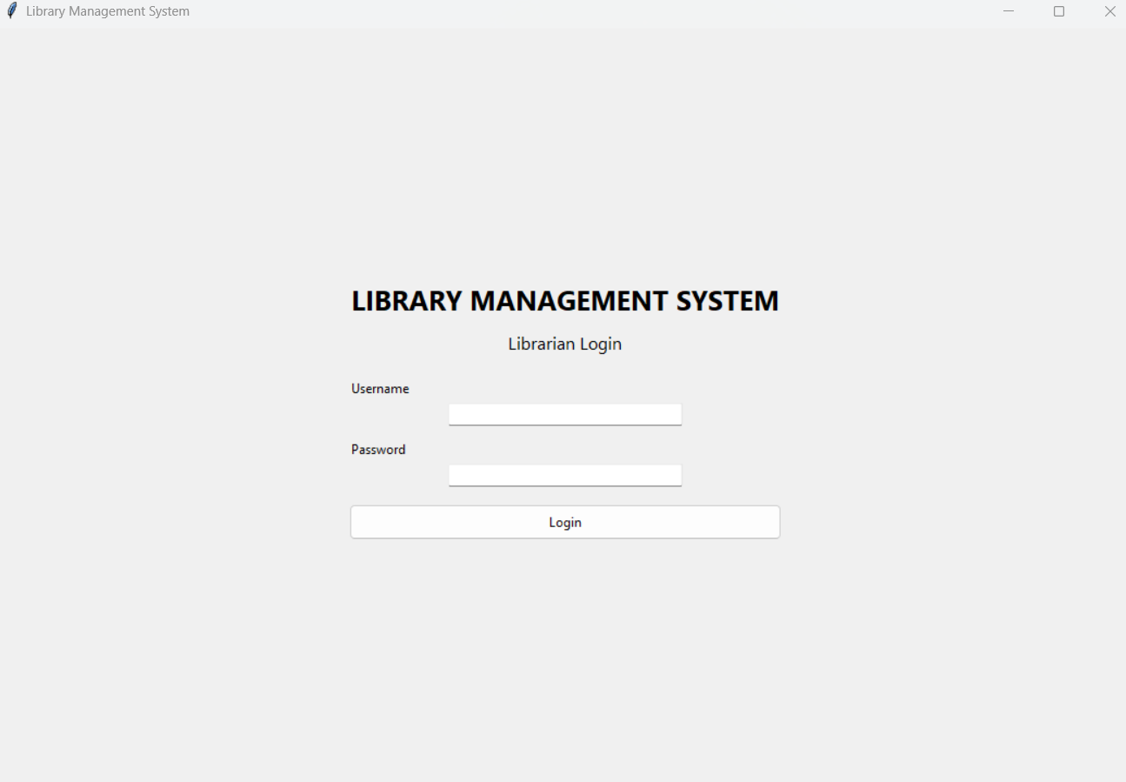
Figure 3: Librarian Login Screen
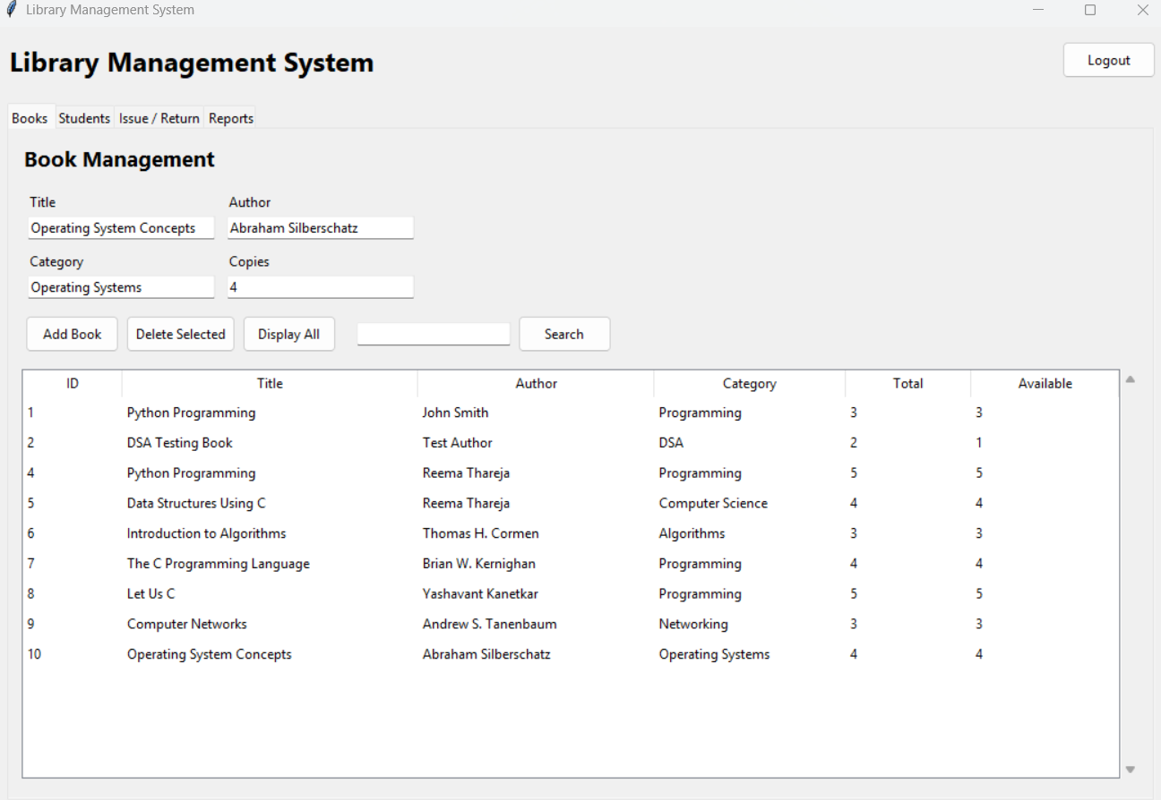Figure 4: Main Dashboard/Book Management
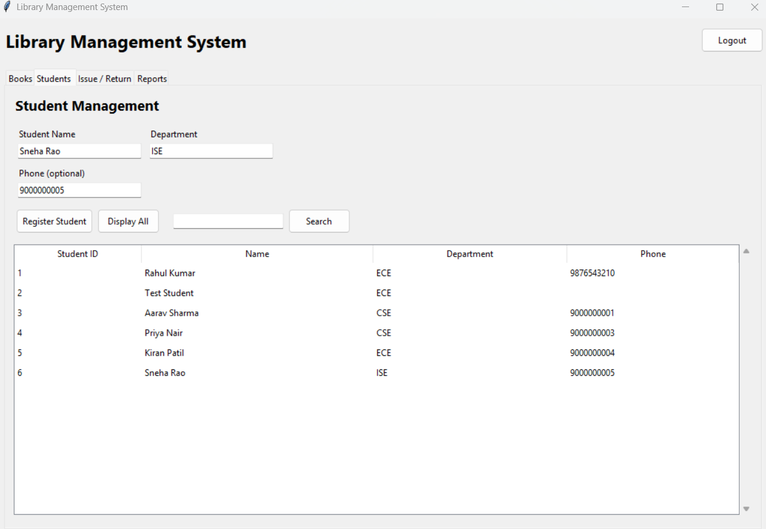
Figure 5: Student Management
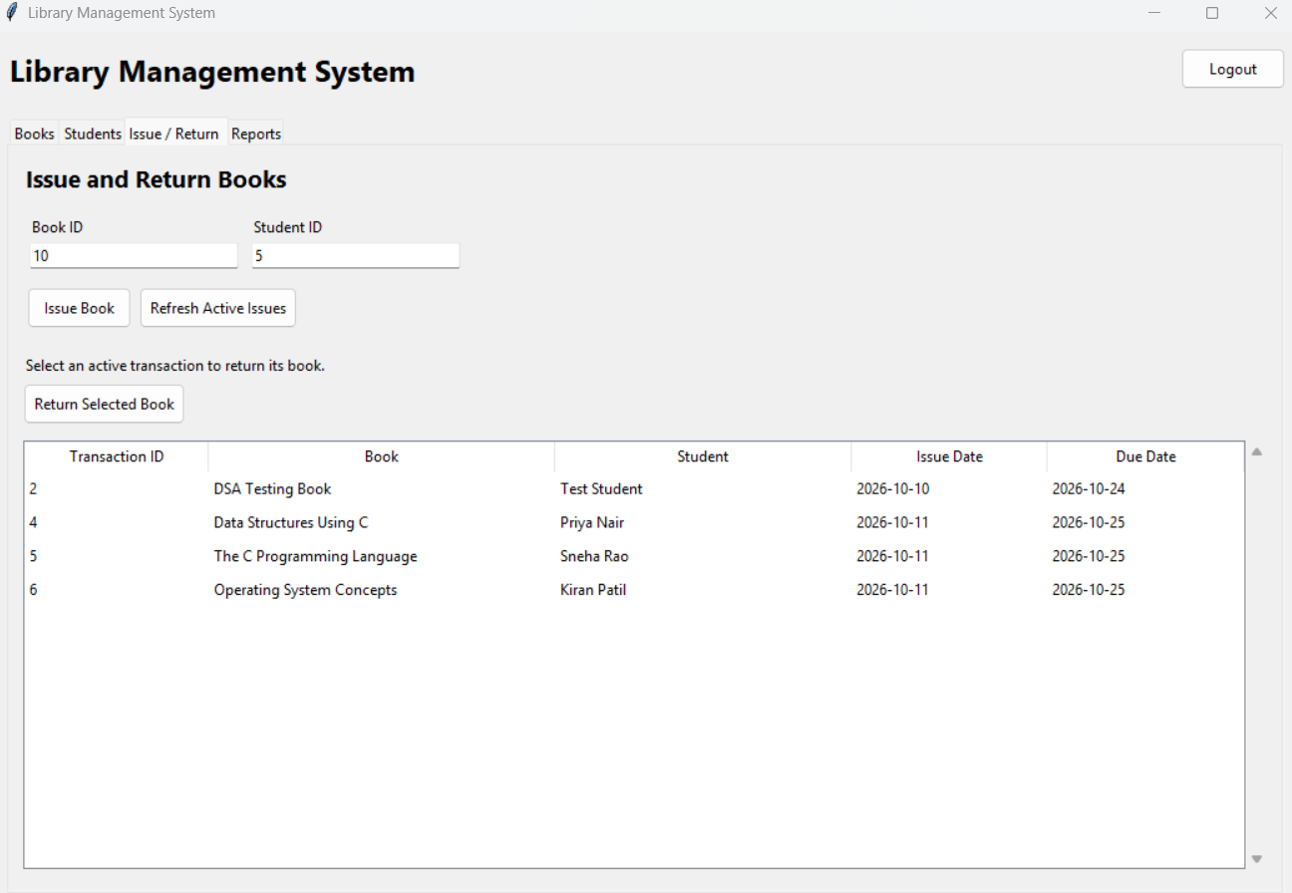
Figure 6: Issue and Return Operations
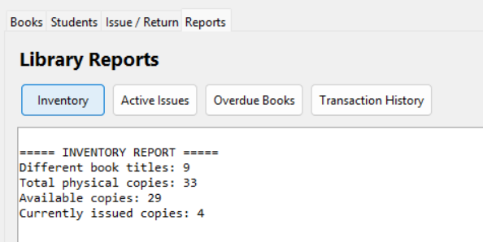
Figure 7: Report/Inventory
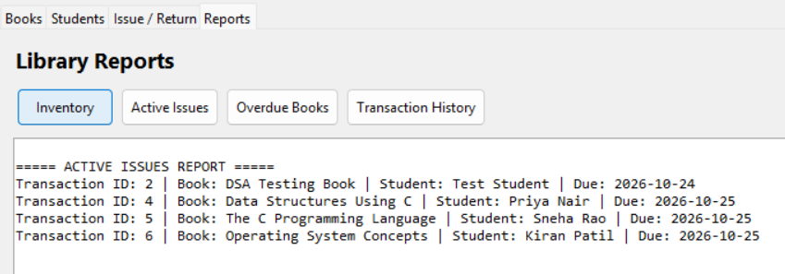
Figure 8: Report/Active Issues
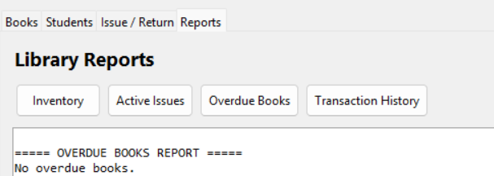
Figure 9: Report/Overdue Books

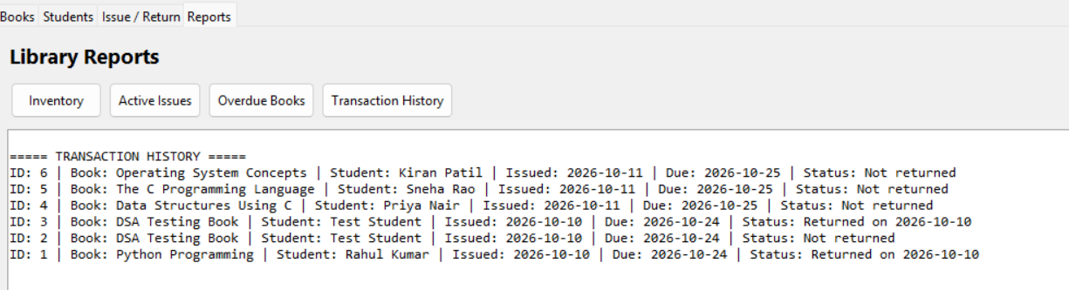
Figure 10: Report/Transaction History
24. ADVANTAGES
The Library Management System provides several advantages over manual library record management.
- Organized Record Management: Book, student, user, and transaction records are stored in a structured SQLite database.
- Easy Book Search: The librarian can search for books using supported identifiers and keywords.
- Accurate Inventory Updates: Available-copy counts are updated during book issue and return operations.
- Improved Data Retrieval: The application allows records and reports to be accessed through a graphical interface.
- Transaction History Preservation: Books with transaction history are protected from deletion.
- Authentication: The login module verifies passwords using salted password hashes.
- Modular Design: Separate Python modules improve code organization and maintainability.
- Report Generation: Inventory, active-issue, overdue, and transaction-history reports help review library activities.
- Persistent Storage: SQLite preserves records between application sessions.
- Cost-Effective Implementation: The application uses Python and SQLite without requiring a separate database server.
25. LIMITATIONS
Although the Library Management System supports the main activities of a small library, it has certain limitations.
- The application is designed as a desktop application and does not provide a web or mobile interface.
- Its current functionality focuses on librarian operations rather than separate student accounts.
- Barcode scanning and RFID-based book identification are not implemented.
- Automated email or SMS reminders for overdue books are not available.
- Online reservations, fine payments, and advanced circulation policies are outside the current implementation.
- The application has not been designed as a distributed, multi-branch library management platform.
- Its performance and scalability have not been evaluated through large-scale benchmarks.
These limitations define the current scope and provide opportunities for future improvements.
26. FUTURE SCOPE
The Library Management System can be enhanced in several ways to improve its functionality and usability.
- Web-Based Interface: Develop a web application so authorized users can access the system through a browser.
- Student Login: Introduce separate student accounts for viewing borrowing history and book availability.
- Barcode or RFID Integration: Automate book identification and reduce manual data entry.
- Automated Notifications: Send reminders for upcoming due dates and overdue books.
- Fine Management: Introduce configurable late-return fines and payment tracking.
- Advanced Search and Sorting: Add more search filters and sorting options for book records.
- Data Backup and Recovery: Implement convenient backup and restoration facilities.
- Enhanced Reporting: Add date-based reports, usage statistics, and graphical summaries.
- Improved Access Control: Introduce additional user roles and permissions where required.
- Cloud or Server-Based Database: Consider a suitable server-based architecture if the system grows to support multiple simultaneous users or branches.
These enhancements could transform the current desktop application into a more comprehensive library management solution.
27. CONCLUSION
The Library Management System was developed using Python, Tkinter, and SQLite to simplify the management of books, students, and borrowing transactions. The application provides features for librarian authentication, book management, student registration, issue and return processing, searching, and report generation.
The project demonstrates modular programming, database connectivity, input validation, password hashing, and transaction handling. Updating available-copy counts during issue and return operations helps maintain accurate inventory information. The reporting module provides useful information about inventory, active issues, overdue books, and transaction history.
Testing reported during development confirmed that the major application functions operate as expected. The project also provides practical experience in applying programming and database concepts to a real-world problem.
Although the current implementation is intended for basic desktop library operations, it provides a foundation for future improvements such as barcode integration, automated notifications, enhanced access control, and web-based access.
Overall, the project achieves its main objective of providing an organized and user-friendly application for basic library management.

